

College of Engineering: EEC 136B

Agricultural Rover

Team Charlie

**19th March 2021**

Aakansha Bhatt, Anshu Paudyal, Ingmar Diaz,

Michael Foster, Raunaq Chopra, Yang Ye

# 

**1.0 Introduction** **3**

**2.0 Features** **3**

2.1 Solar Fuel Gauge system 3

2.1.1 Rover system 4

2.1.1.1 Solar Panel 4

2.1.1.2 Capacitor 5

2.1.2 Interactive Lights 5

**3.0 Sensors** **5**

3.1 LIS3DH Accelerometer 5

3.2 ZMR250 camera 6

3.3 OLED Display SSD1306 6

**4.0 System Design** **6**

4.1 OLED Display 6

4.2 3D Enclosure 9

**5.0 PCB Design and Circuit Implementation** **10**

**6.0 Video transmission and Reception Firmware** **13**

6.1 TS835 Transmitter. 13

6.2 RC832 Receiver 14

6.3 RGB display screen 14

**7.0 Limitation** **14**

7.1 Energy Consumption 14

7.2 Hardware Limitation 15

**8.0 Project Budget** **15**

**9.0 Conclusion** **15**

**10.0 References** **16**

# 

# 1.0 Introduction

The project Agricultural rover was started with an idea to build a renewable energy powered device for monitoring crops condition, infestation, temperature, moisture level etcetera, however due to time constraints and other factors we only have the solar fuel gauge part working as of right now. In this report we present the current features, design methods, and process of implementation of our solar fuel gauge system.

The flowchart below shows the features implemented for Alpha prototype and potential future features.

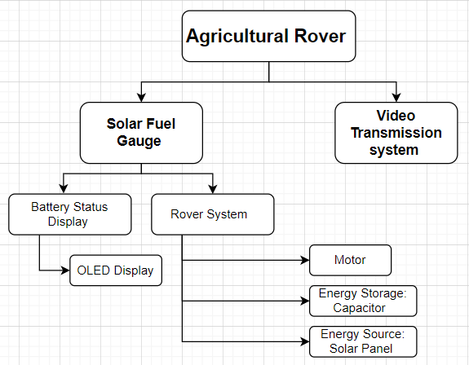

# 2.0 Features

## 2.1 Solar Fuel Gauge system

Solar fuel gauge system includes the rover system and the status display system for the capacitors.

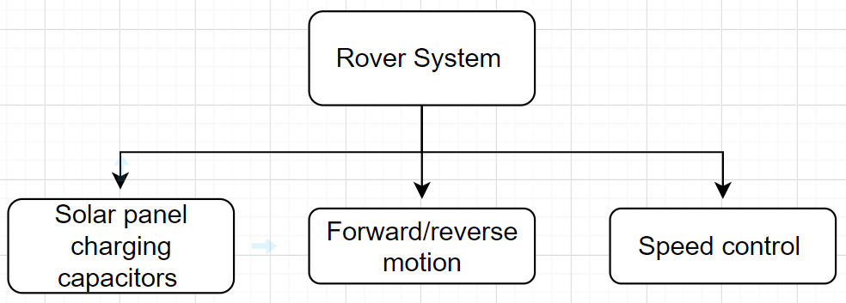

### 2.1.1 Rover system

The rover system includes the motor, solar panel, capacitors, Single Pole Double Throw Switch (SPDT), and the rover. The capacitors are charged using a solar panel and the stored energy is used to run the rover. The manual switch is used to switch between the charging and discharging state of the capacitor. The picture below shows the labeled diagram of all the components used in the rover system. The potentiometer is used to control the speed of the rover.

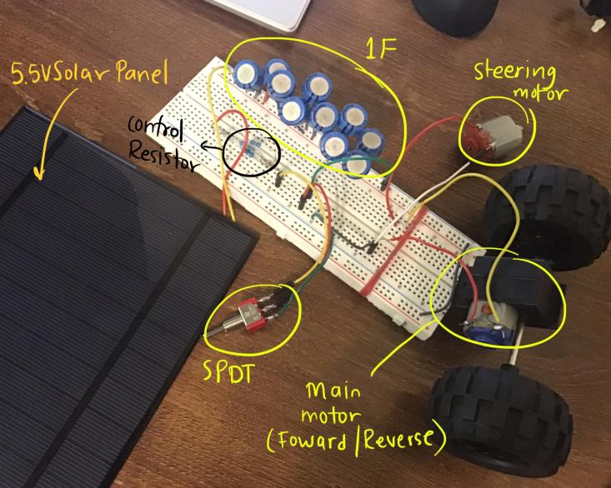 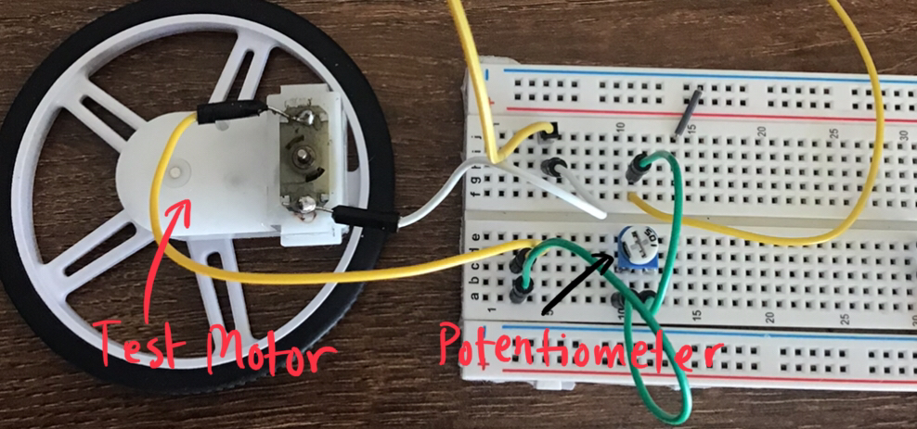

#### 2.1.1.1 Solar Panel

The solar panel is used to charge the capacitor in this project. The specification of the solar panel is given below:

* Power: 2.5W
* Voltage out: 5V
* Capacity: 500mAh

#### 2.1.1.2 Capacitor

For this project, the capacitors are used as the energy source. They are charged using the solar panel and the energy stored is used to run the rover. The capacitor analysis is presented below.

| Capacitors | **Analysis** |
| --- | --- |
| Rechargeable Battery that came with the rover | 3.7V  capacity of 400mAh  energy stored is 1.48kJ |
| 18mF | Voltage Rating: 16 V  Stored Charge: 0.288 C  Stored energy: 0.002304 kJ  Capacity: 0.14400000 mAh |
| 1F | voltage rating: 5.5V  charge stored: 5.5C  stored energy: 0.015125 kJ  Capacity: 2.7mAh |

### 2.1.2 Interactive Lights

* Multi colored LEDs (Green, 2xYellow, Red)
* 4x1K Resistors
* Purpose: Originally used to detect fuel guage status, but after consulting and finding out it drew too much voltage, it is now used as a light display for the rover.

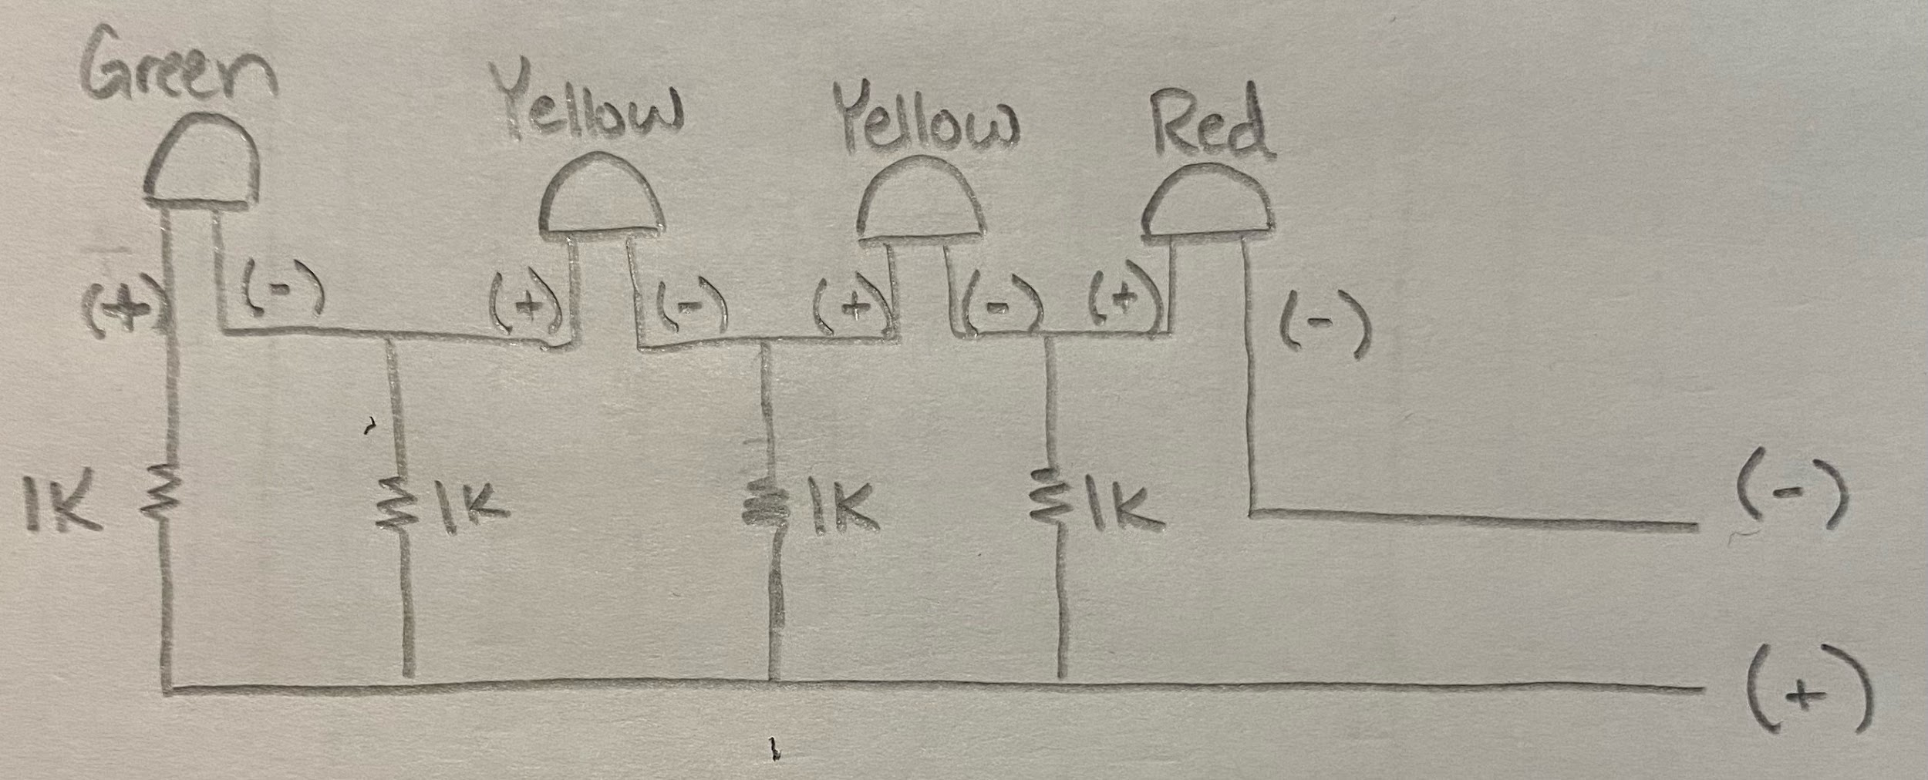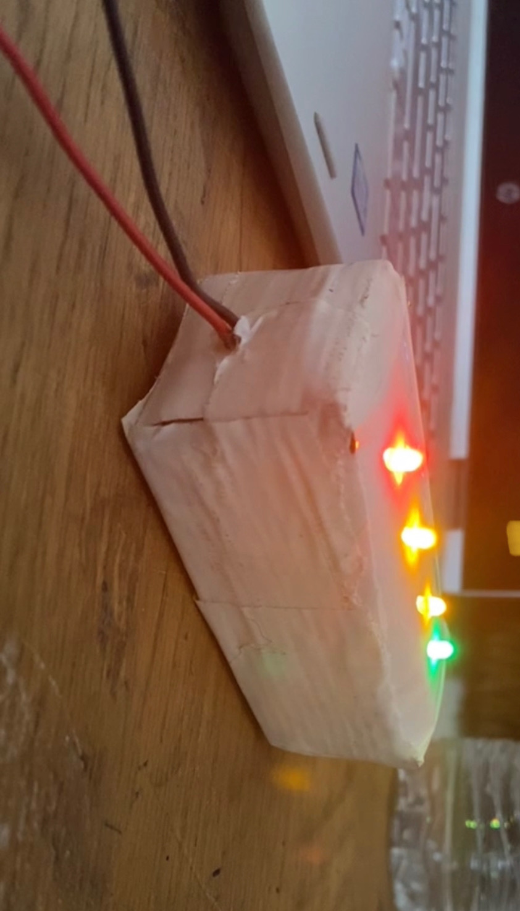

# 3.0 Sensors

## 3.1 LIS3DH Accelerometer

* Supply voltage: 1.7-3.6V
* I2C/SPI digital output interface
* Motion detection
* Embedded temperature sensor
* Purpose: To record the acceleration and speed of the rover and also measure the temperature outside.

## 3.2 ZMR250 camera

* Resolution: 1200TVL resolution for capturing real time video..
* Size: 25mm*25mm camera
* Camera type: 2.8mm Lens and 1/3" CMOS sensor.
* Additional feature: low power consumption, capable with 5 Voltage power supply system, easy for installing.
* Purpose: Capture real time video.

## 3.3 OLED Display SSD1306

* Power: 3-5V
* Communication: I2C
* Pixels:128x64
* Purpose: Used to display different types of data. Such as Speedometer data, Fuel Gauge Charge, Temperature, and Moisture level.

# 4.0 System Design

## 4.1 OLED Display

The OLED display has 4 pin connectors: VCC, GND, SDA, SCL. The display will be powered by the PSOC and it will be connected to the SDA and SCL pins to communicate and display.

Currently we are able to display messages successfully using PSOC .We did not want to “reinvent the wheel” when it came to using a display library. To achieve this we used a library that someone had previously created in PSOC and modified the functions to display our desired output. We can see a message displayed in the image below.

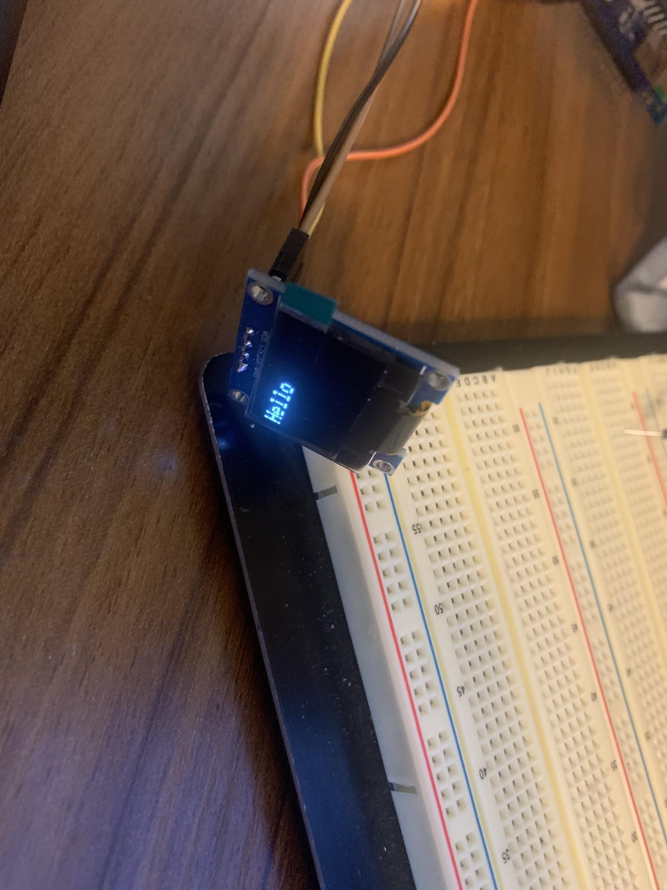

We will be using an Analog to Digital Converter in PSOC to convert the signal from our fuel Capacitance charging circuit and then convert it into digital values and then using software to determine in what range these values fall in using conditional statements. Depending on the range the display will indicate charge level. In the images below you can see 1.) The analog circuit schematic of OLED display implementation which is simply a voltage divider connected in parallel to the load of the motor. Using the PSOC and a bjt transistor we can read into the psoc and send an interrupt signal to enable/disable the bjt which will be acting as a switch, that we can limit voltage consumption. 2.) Top Design containing an ADC block and I2C communication block. 3) Our code where we read in the voltage values and scale accordingly to then display on our OLED. 4.) Actual implementation of our design..

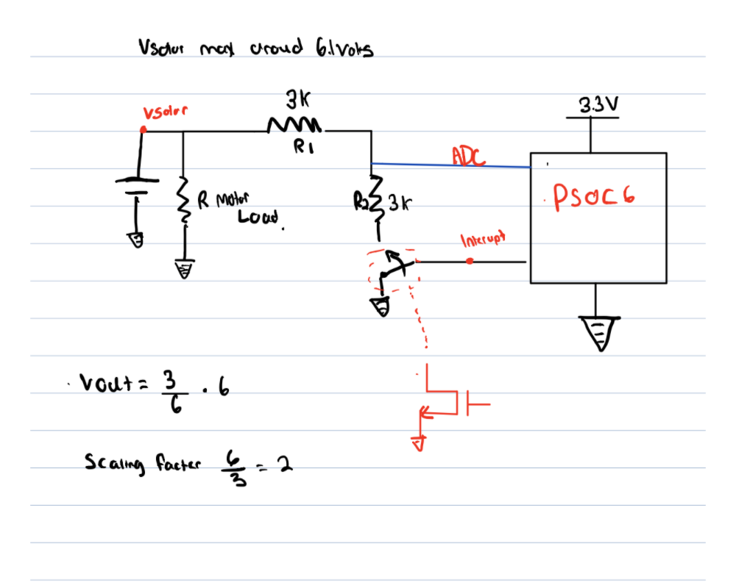

1.)Analog circuit schematic

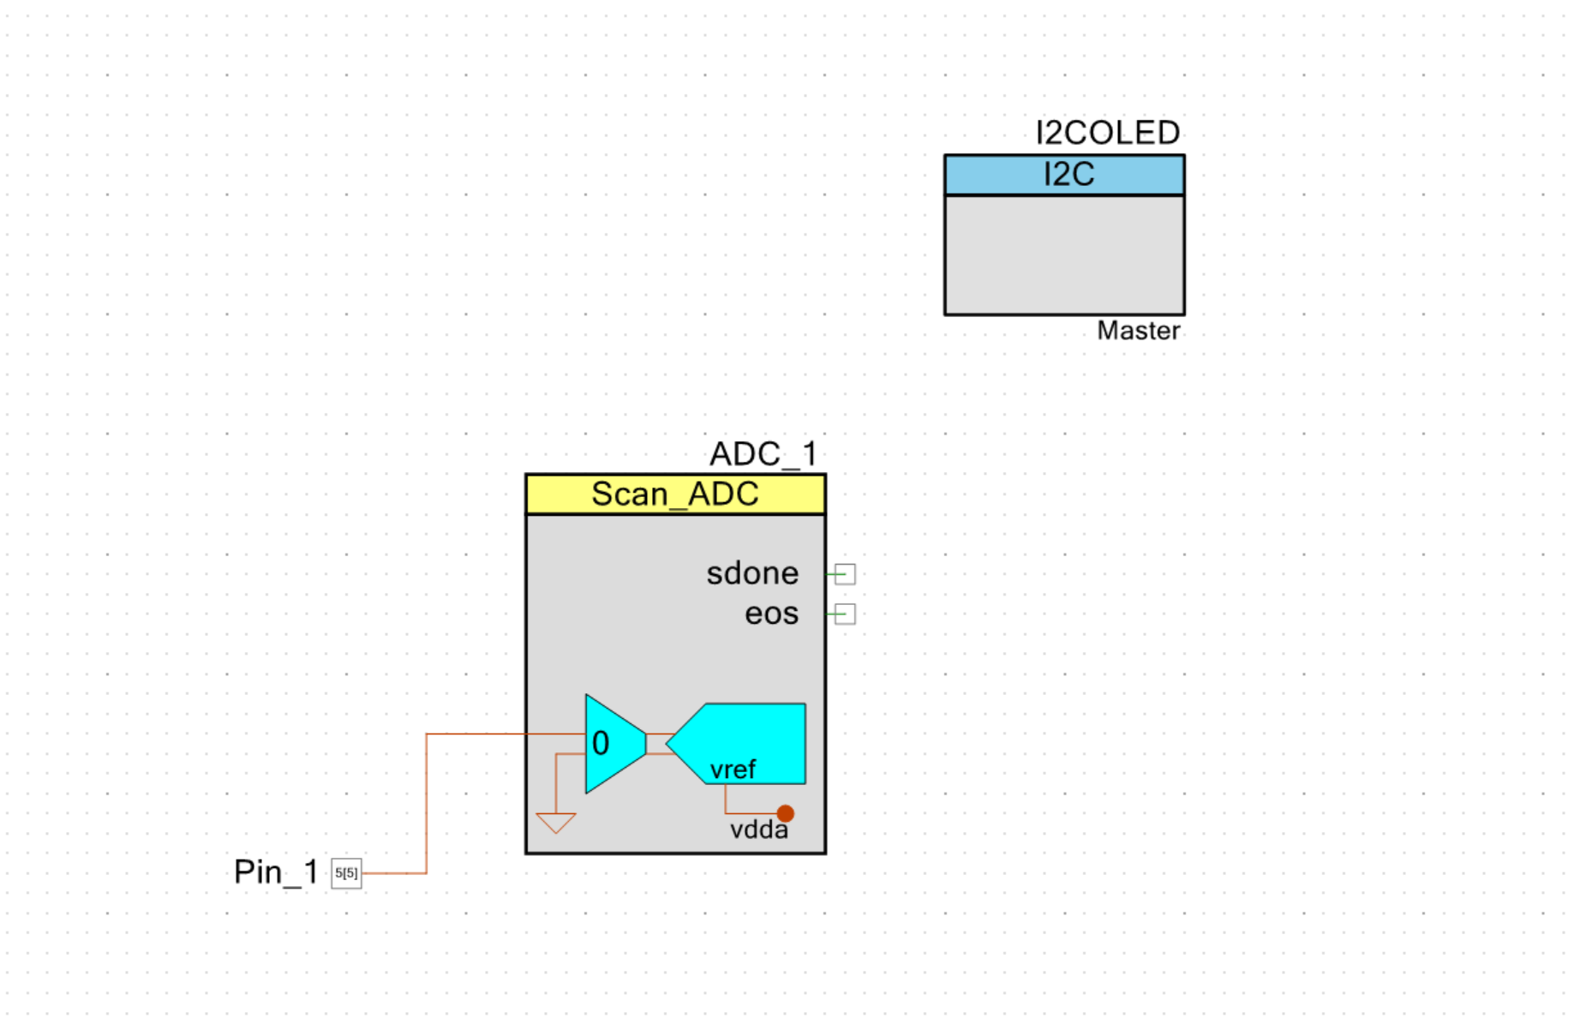

2.)Psoc Top Design

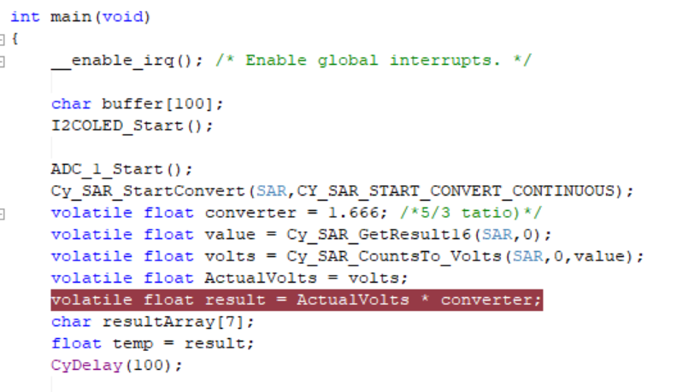

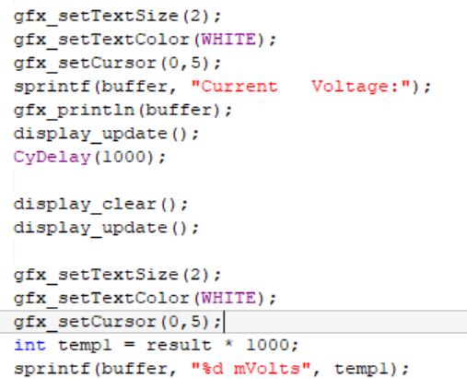

3.)Psoc code(Top converting ADC value and scaling, bottom displaying)

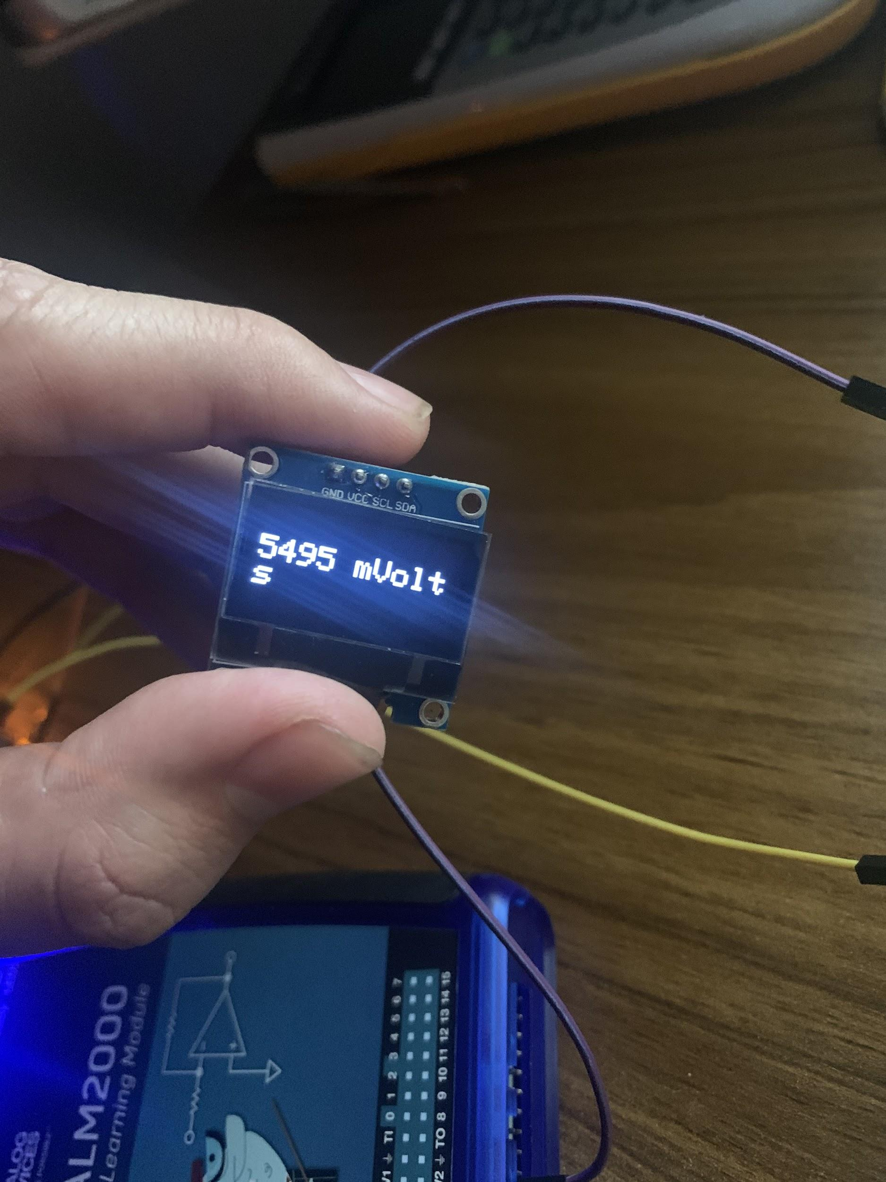

**Future Implementation/Improvements:**

We would also like to display speedometer and temperature data by connecting the accelerometer sensor to our display as well and using software to switch inputs in PSOC.

The last data we want to display is GPS location & Humidity we will most likely have to purchase another sensor and use PSOC to achieve this.

## 4.2 3D Enclosure

For our 3D enclosure we used a simple box and lid implementation using Fusion360 and Altium, which can be seen in the images below.

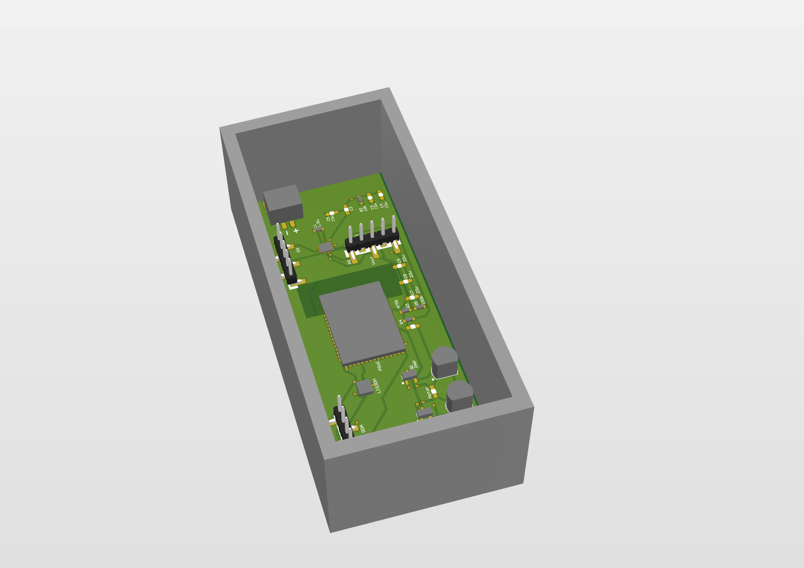 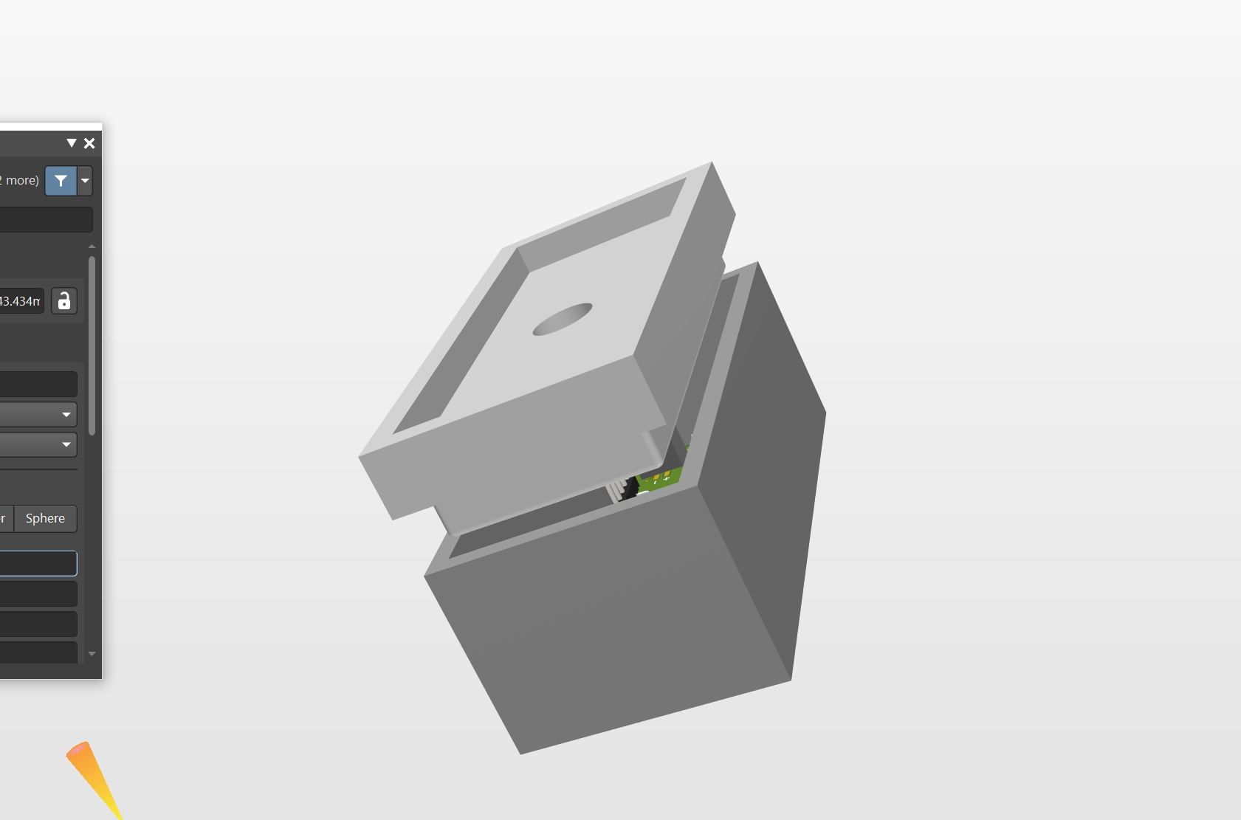

In the first image we can see our PCB in the box and in the second image we see the Lid being placed on top of the enclosure. You can see a hole that goes through the lid, we did this in order to feed the wiring and connections of off board components such as our OLED Display, Solar Panel, and Motors.

**Future Implementation/Improvements:**

Eventually we would like to directly mount our display on top of the enclosure possibly even the solar panel or instead create more holes to reduce wiring confusion to our offboard components. Also we would also like to resize our original enclosure size as our dimensions of our PCB have changed. In theory our enclosure would be mounted on the top of the chassis of the rover.

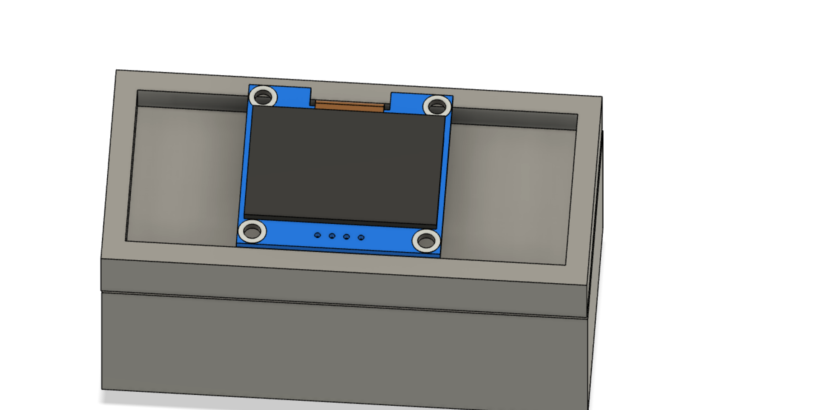

# 5.0 PCB Design and Circuit Implementation

Below is a basic overview and flowchart of the overall circuit design.

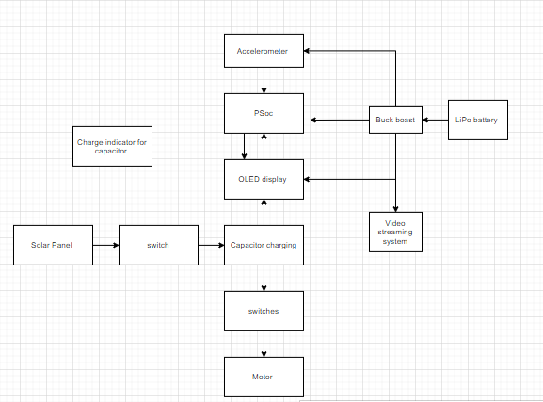

The solar panel is connected to the capacitor through a three-way switch. Upon toggling this switch, the capacitor connects to the motor but stops receiving solar power. The OLED display and the PSoC module collectively record and display the amount of charge on the capacitor. Since solar power is used only to operate the motor, a LiPo battery is used for other modules. A buck-boost converter adjusts the voltage appropriately, and supplies power to the PSoC, Accelerometer and the OLED display.

The resulting Altium schematic is as follows:

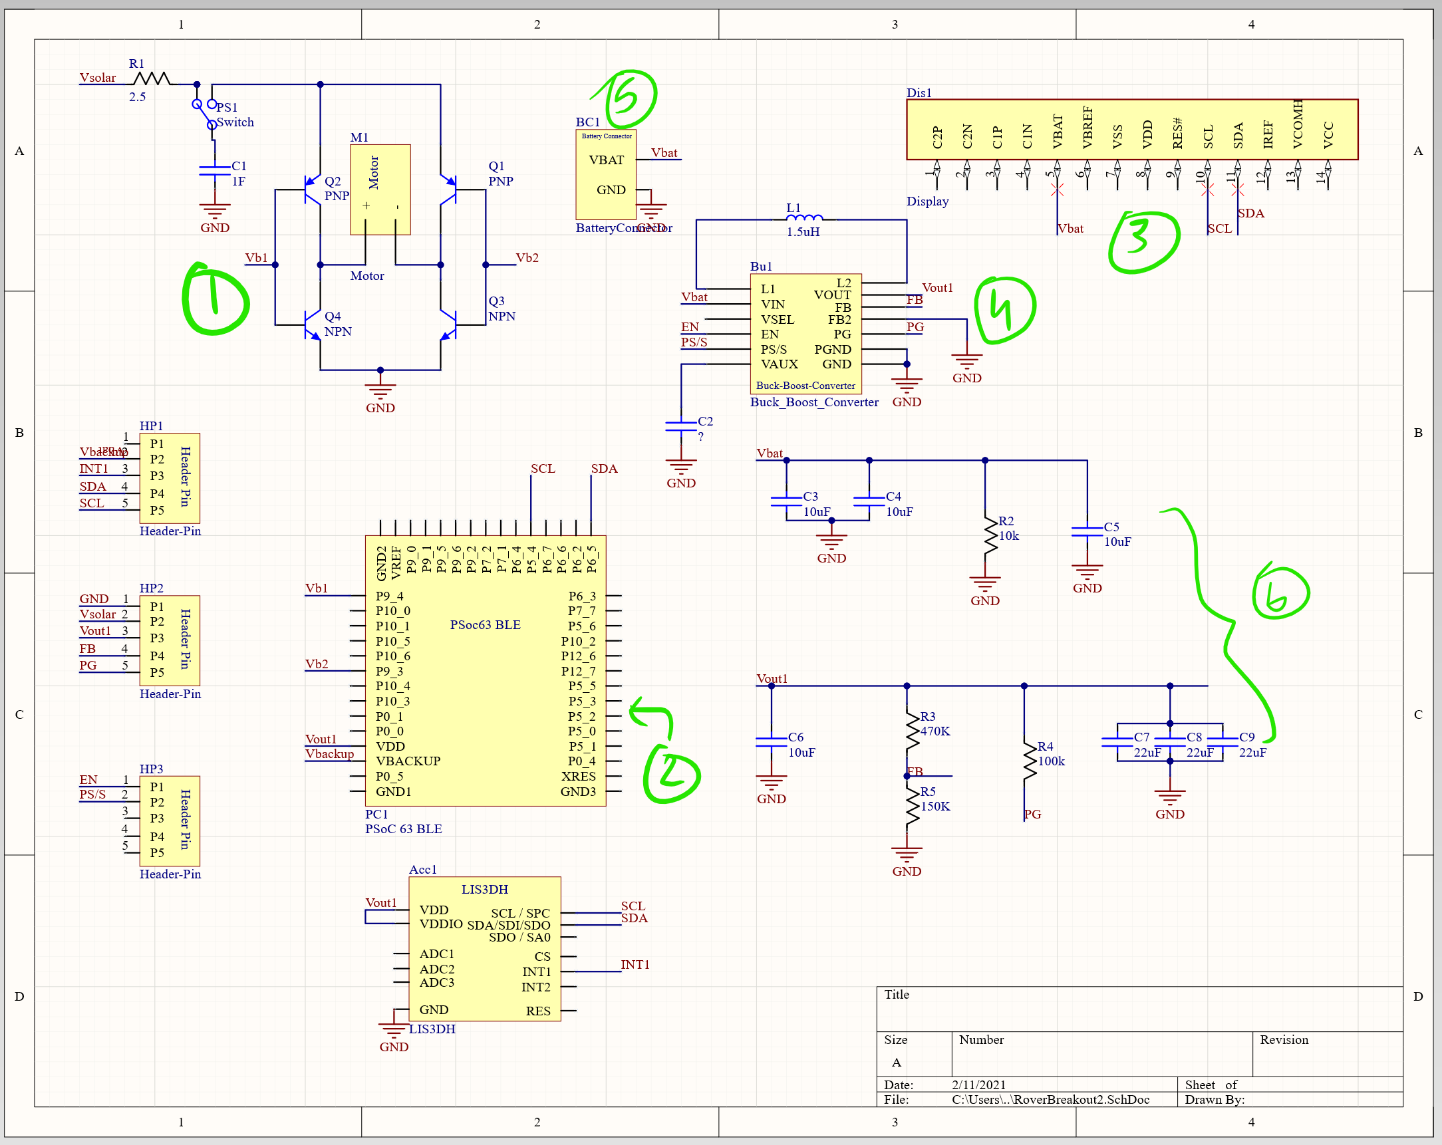

1. This is the circuit that connects the capacitor to the solar panel and the motor. The three-way switch allows the capacitor to remain connected to either the solar panel, or the motor, but not both. This ensures that the motor only runs when the capacitor is supplying the power to the motor. The BJTs around the motor create an H-bridge. The bases of these BJTs are controlled digitally by the PSoC (2). One of the inputs (to Q2 and Q4) is going to be the complement of the other (Q1 and Q3). This layout ensures that the current flows either from Q1 to Q4 (right to left in the motor) or Q2 to Q3 (left to right in the motor). This allows us to run the rover in both directions.
2. The PSoC module connects to the transistor bases, the display module (3) and the accelerometer (7). In the future, we would implement a design that allows the PSoC to detect the capacitor charge as well.
3. The oLED display receives a signal from the PSoC to display the temperature readings and humidity. In the future, it would also display the capacitor charge levels.
4. Receiving power from the LiPo battery (5), the Buck-boost converter steps the voltage down to appropriate levels for the PSoC, oLED and the LIS3DH accelerometer.
5. The connector for the LiPo battery
6. Additional circuitry for appropriate operation of the accelerometer and buck-boost converter, as in the datasheets provided by manufacturers.

The final PCB design.

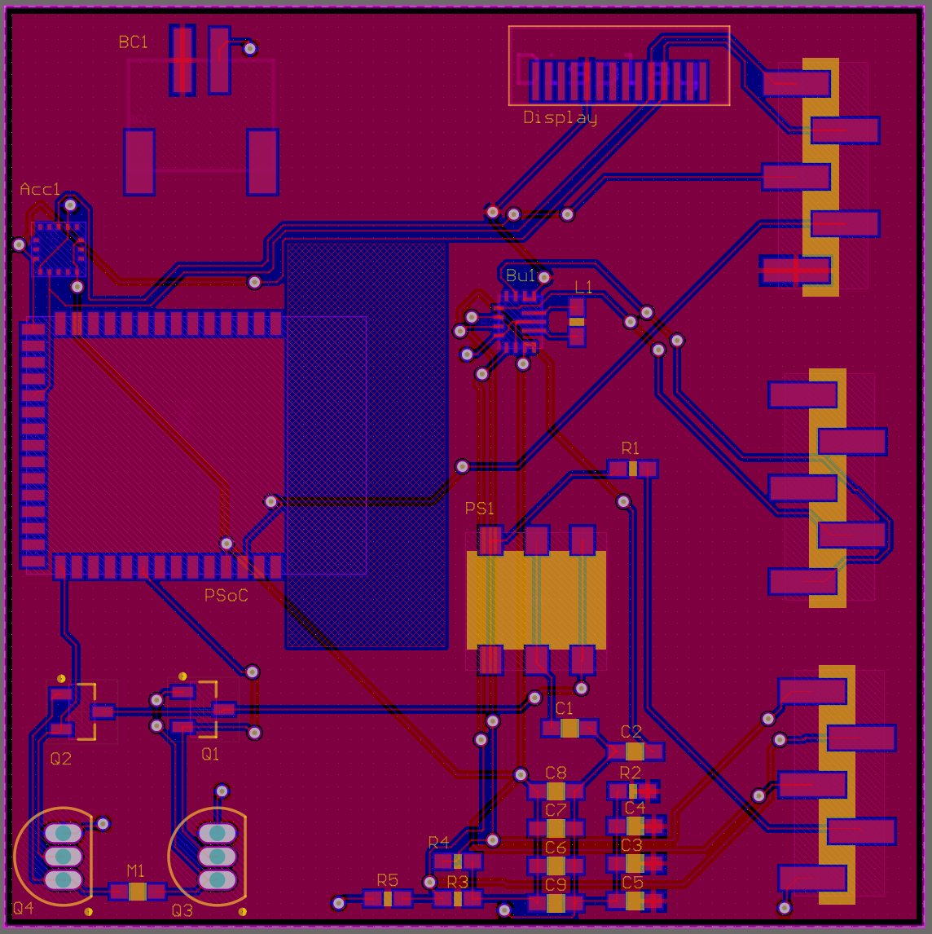

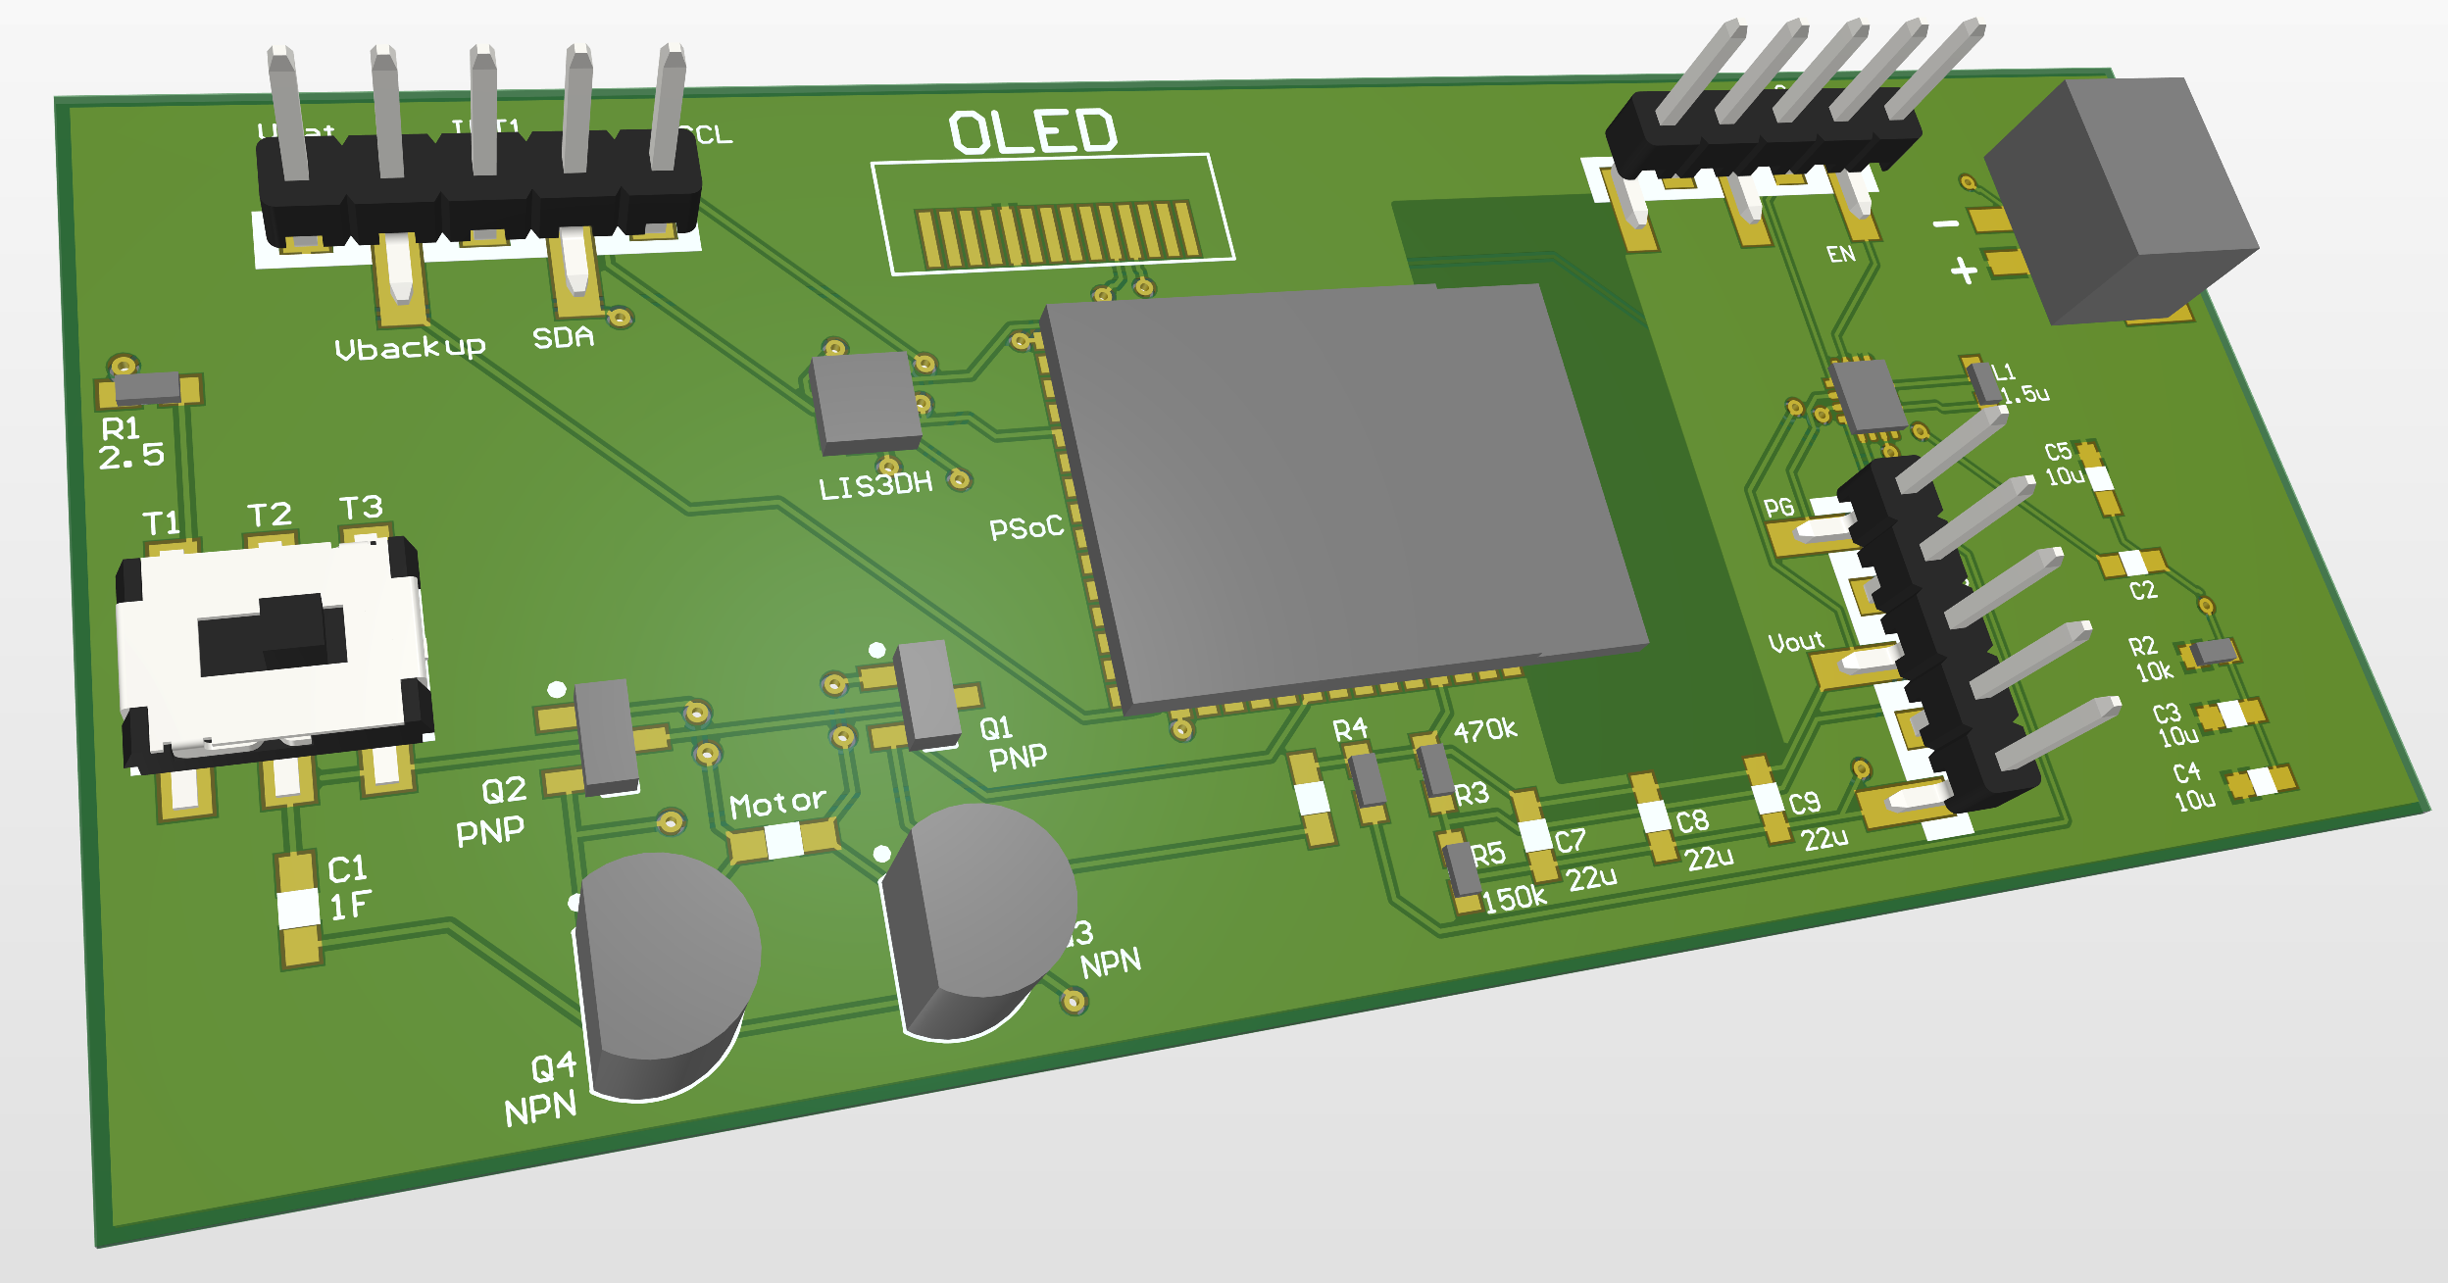

# 6.0 Video transmission and Reception Firmware

## 6.1 TS835 Transmitter.

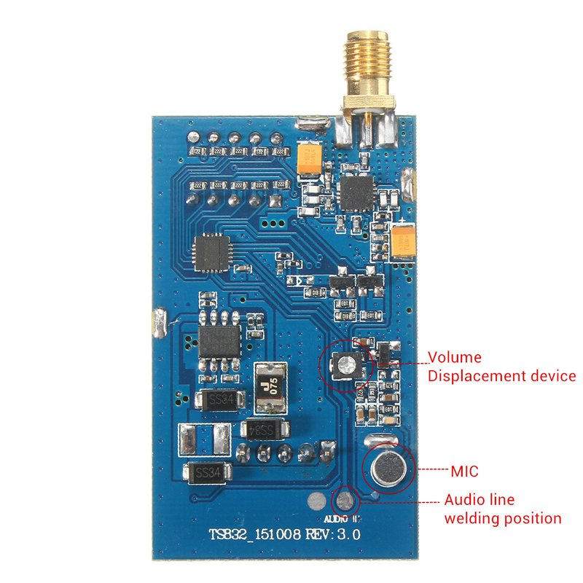

Boscam 5.8G 600mw 32CH TS835 FPV Wireless Audio Video Transmitter w/ 5V1A output. Antenna Gain: 2db Frequency: 5.8G. Transmitting Power: 600mA. Power Input: 7-28V (3S Lipo suggested). Video Format: NTSC / PAL Auto. Working Current: 220mA at 12V. Audio Bandwidth : 6.5M. Video Bandwidth: 8M .Weight: about 22g . Dimension: 54x 32x 10mm(excluding antenna). Connector: transmitter module side RP-SMA jack, antenna RP-SMA plug Features: 32 channels choice to get the best transmitting quality. Compatible with A,B,E and F frequency bands Smaller size with lighter weight. 32 CH compatible with all FPV 5.8g receivers. 5.8G 600mW 32 Channels AV transmitter. 600mW transmitter power assures 5KM distance in open area, 5-8 KM is available if work with the bigger gain antenna.

## 6.2 RC832 Receiver

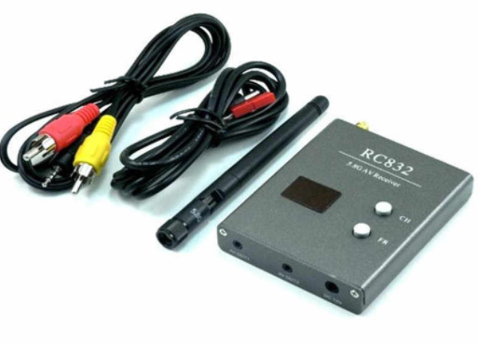

Power Supply: DC 12V. Antenna impedance: 50¦Ø. Video impedance: 75¦Ø. Working Frequency: 5.8GHz. Available Channel: 40CH. Consumption Current: 200mA, Max. Antenna Gain: 2dbi. Antenna Connector: RP-SMA. Audio Carrier: 6.5MHz. Video Format : NTSC/PAL. Dimension: 80x65x15mm. Weight: 85g

## 6.3 RGB display screen



Display the AV video signal in RGB color mode.

# 7.0 Limitation

## 7.1 Energy Consumption

The energy consumption of the Video AV signal transmitter is relatively high for the Rover. It requires an independent 12 Voltage power supply system, but the effective transmission distance of the Video AV signal transmitter can reach 3 kilometers without any signal relaying device.

|  | Capacity | Voltage | Power or Energy |
| --- | --- | --- | --- |
| OLED | 20mAh | 1.6-3.3V | 66mW |
| Solar Panel | 500mAh | 5V | 2.5W |
| Capacitors | 2.75mAh | 5.5V | 15.1mW |
| Rechargeable Battery | 400mAh | 3.7V | 1.48kJ |
| PSOC6 | 20mAh | 1.7-3.6V | 72mW |

## 7.2 Hardware Limitation

The weight of the solar fuel gauge on the rover system seems to be a problem because it was noticed that the run time decreased almost by 25% when the solar gauge was placed on top of the rover.

# 8.0 Project Budget

**Bill of Materials and Project Budget:**

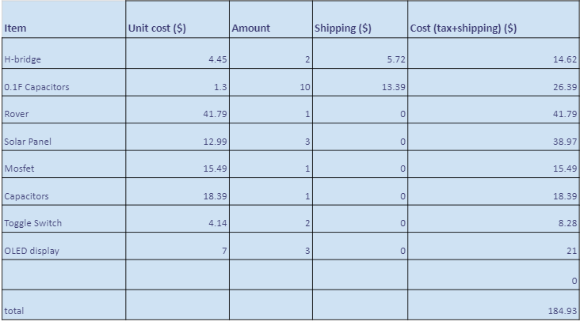

# 9.0 Conclusion

This concludes our Beta prototype for the agricultural rover. We presented the solar fuel gauge and the video transmission and reception features of the project. The rover described in this paper has a general application, therefore it can be modified and implemented as needed. In addition, we can further improve the rover system by taking in account the limitations.

# 10.0 References

OLED Reference

<https://drive.google.com/file/d/1EsBkc2XF6p0jE2KBtCDV365emnpUxBAM/view?usp=sharing>

Power Analysis

<https://www.omnicalculator.com/physics/capacitor-energy>  
<https://jumk.de/math-physics-formulary/capacity.php>